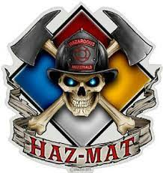Orange Helmet Training
Hazardous Materials Group

Announce: Confined Space Awareness

Dates: August 14th, 2021

Times: 8:00 a.m. – 5:00 p.m.

Location: Red Helmet Training Center
10601 Church St #107
Rancho Cucamonga, CA 91730

Instructor: Greg Coon

Fees / Materials: $150.00 – Payable to Red Helmet Training
Covers cost of CSFM Materials and Certificate

Class Description: This course provides instruction in identifying permit and non-permit required confined spaces, hazards associated with confined spaces, state regulations, communications, and equipment requirements. This course does not qualify participants to enter confined spaces. This course is approved by the California State Fire Marshal and California Fire Service Training and Education System.

Prerequisites: None
To register for this course please visit the web site.

www.RedHelmetTraining.com

