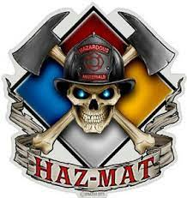Orange Helmet Training
Hazardous Materials Group

Announce: Haz-Mat First Responder Operational

Dates: August 7-8, 2021

Times: 8:00 a.m. – 5:00 p.m.

Location: Red Helmet Training Center
10601 Church St #107
Rancho Cucamonga, CA 91730

Instructor: Greg Coon

Fees / Materials: $240.00 – Payable to Red Helmet Training
Covers cost of CSTI Materials along with CSTI Certificate
Class Description: Haz Mat operations level are individuals who respond to releases or potential releases of hazardous substances as part of the initial response with the purpose of protecting people, property, or the environment. They are trained to respond in a defensive fashion without trying to stop the release. Their function is to contain the release from a safe distance, keep it from spreading, and prevent exposures. This CSTI class meets the requirement for Cal Fire and the Calif SFM Firefighter 1 Certification. This 16-hour class is not the CSTI Pro Board version.
Prerequisites: None
To register for this course please visit the web site.
www.RedHelmetTraining.com

